***Champagne Armand De Brignac Blanc***

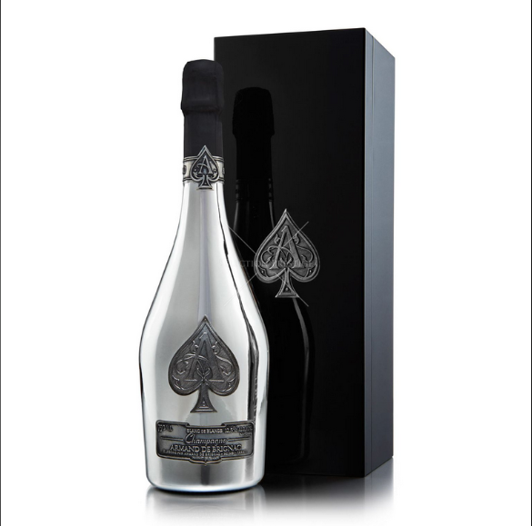

*"France is not inferior to any other country on the market today in terms of wine production in general. And this bottle of white wine is a typical product from the beautiful country of France.  
  
Users will feel impressed about this wine bottle from the first meeting by a beautiful appearance right from the outside of the wine bottle. It's a soft, nostalgic light white color, the color of autumn, the color of people who are delicate, flexible and rhythmic.  
  
Moreover, the taste in the wine is the factor that scores users. It is the fresh aroma from the Chardonnay grape variety, the main ingredient that makes up the flavor of the wine. In addition, the wine also has aromas of many other ripe fruits such as oranges, tangerines or grapefruits of all kinds. Followed by aromas of lightly buttered pastry, pear aromas, and a hint of gingerbread. On the palate, flavors of guava are complemented by sweet spices and a fresh mineral finish…”*